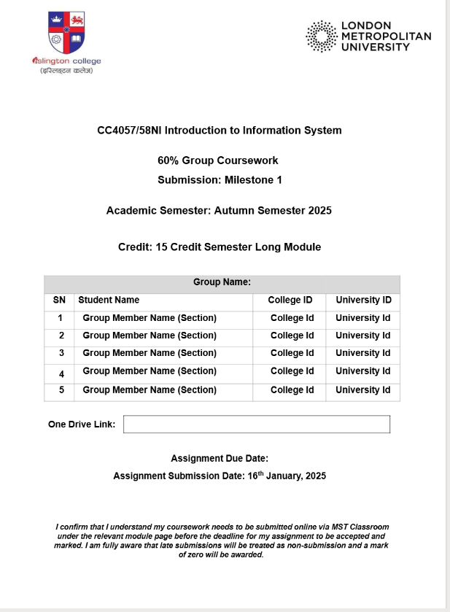
CC4057/58NI Introduction to Information System
60% Group Coursework
Submission: Milestone 1
Academic Semester: Autumn Semester 2025
Credit: 15 Credit Semester Long Module
SN | Student Name | College ID | University ID
1 | Group Member Name (Section) | College Id | University Id
2 | Group Member Name (Section) | College Id | University Id
3 | Group Member Name (Section) | College Id | University Id
4 | Group Member Name (Section) | College Id | University Id
5 | Group Member Name (Section) | College Id | University Id
One Drive Link:
Assignment Due Date:
Assignment Submission Date: 16th January, 2025
I confirm that I understand my coursework needs to be submitted online via MST Classroom under the relevant module page before the deadline for my assignment to be accepted and marked. I am fully aware that late submissions will be treated as non-submission and a mark of zero will be awarded.

